Advanced Rich Internet Applications

Master of Web Technologies Project

**Project Title**: FitApp – Fitness Monitoring Application

**Project Team:** Grzegorz Filipek, x12107590, [grzegorz.filipek@student.ncirl.ie](mailto:grzegorz.filipek@student.ncirl.ie)

Jonathan Harris, x13118901, [Jonathan.Harris@student.ncirl.ie](mailto:Jonathan.Harris@student.ncirl.ie)

**Application URL:** [**http://vast-tundra-3435.herokuapp.com/**](http://vast-tundra-3435.herokuapp.com/)

**GitHub Repository:** [**https://github.com/gfpk/aria.git**](https://github.com/gfpk/aria.git)

_________________________________________________________________________________

**Contents**

**Project Motivation 3**

**Project Scope 3**

**Area of Contribution 3**

**State of the Art Review 4**

**Responsive Frameworks analysis 5**

**Current Fitness applications 6**

**Conclusion 6**

**Our Solution 7**

**User Interface Design 7**

**FitApp Responsive Menu 8**

**Landing Page 9**

**Training Maps 10**

**Training Statistics 11**

**Training Plans 13**

**Architecture 14**

**Application Architecture 14**

**Security 15**

**Toolkits and Frameworks 15**

**Data Transfer Strategies 16**

**Evaluation and Testing 16**

**Summary 17**

Project Motivation

Project Scope

The objective of this project is to design and develop a web based application that will link users through their Facebook accounts in a way that will help them plan an achievable fitness regime and track their progress against a set of performance milestones and fitness objectives. Due to a limited time constraints this project will focus on a rapidly developing a simple responsive framework that will meet as many of the high level requirements (listed in Project Requirements below) as the two week time constraint allows.

This framework should be fully responsive so as to allow users to interact with other users of the application on their mobile devices in a real-time manner as they go from step-to-step in their personal fitness programme.

Project Requirements

The high level function requirements for the FitApp Application are as follows:

1.) Users can Logon and Register using their Facebook User id and password.

2.) Users can see an overview of upcoming events in their local area.

3.) Users can construct a fitness training program from a list of predefined activities and milestones.

4.) Users can track their performance metrics e.g. distances covered, calories burned, events attended.

Area of Contribution

The area of contribution is in the recreation environment specifically personal fitness. The problem associated with this area is providing motivation for the individual to engage in a structured fitness program. The “FitApp” application aims to provide motivation for the individual by linking them with friends and other groups with similar interests through the popular social networking site Facebook™. The use of applications to track personal training programmes is proving to be a popular way of doing this as claimed by a recent report from mobile analytics firm Flurry[1] whose figures show the use of sports, health and fitness apps grew by 49% on iOS and Android in 2013. The “FitApp” application will enable users to construct a personal fitness programme consisting of an achievable set of pre-defined goals and objectives which are targeted at people who wish to attend public fitness events such as mini-marathons at public fun runs either for the first time or to improve performance from the last event attended. The “FittApp” application portal provides motivation to the individual by using the social accountability associated with sharing their actual recorded performance results with other users of the application.

State of the Art Review

Current RIA development methodologies:

Rich Internet Applications (RIA’s) is the next evolution in web design taking web applications from the traditional flat “catalogue” web design to a more “responsive” web design, meaning that the page design can respond to the type of device being used to view the application and thus provide the best user experience possible within the context of a particular devices capabilities i.e. mobile phone, tablet or desktop screen. This new generation of RIA applications deliver an enhanced user experience through a mixture of smoother graphic content combined with more intuitive navigation tools and a rich mixture of interactive functionality. This enhanced user experience is provided through the use of web technologies based on the newer HTML5 specification in conjunction with CSS3 (Cascading Style Sheets Ver.3) frameworks and a variety JavaScript API libraries. A classic responsive web site example in shown in Fig 1 below:

Fig 1 Multi layered responsive design layout including interactive video:

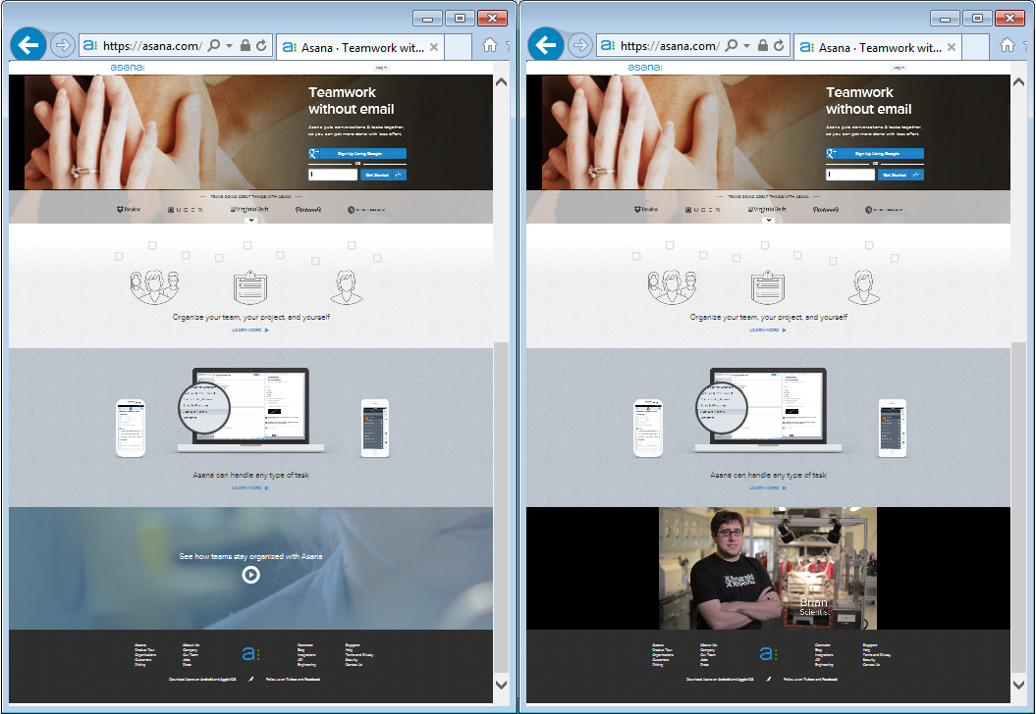

Fig 1: Source: [https://asana.com/](https://asana.com/?utm_source=google&utm_medium=cpc&utm_term=Asana&utm_campaign=G_S_Desktop_Alpha_Brand_EU&mkwid=sbQ0LO6nY&pcrid=34870179556&pkw=asana&pmt=e&pdv=c&gclid=CJ3ynvDLlL0CFWGr2wodn2cAVw)

Responsive Frameworks analysis

There are numerous open source responsive frameworks available for web applications development. The responsive frameworks, boilerplates and tools for front-end web development use in this project are outlined below:

1. Twitter Bootstrap (<http://getbootstrap.com/2.3.2/index.html>**)**

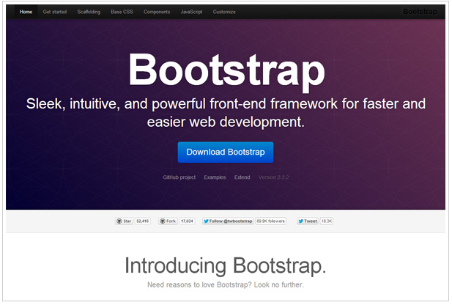This is a modern front-end /UI development framework with a 12-grid responsive layout that uses LESS (Learner CSS) and JavaScript plugins that provide out of the box effect such as image transition effects, streamlined modals, dropdown menus and carousel slideshows as well as typography and link styling. Bootstrap can be expanded by using additional Bootstrap specific add-ons available from open source developer forums which provide additional API’s, themes and interface building tools such as Jetstrap (<https://jetstrap.com/>).

1. Modernizr (<http://modernizr.com>)

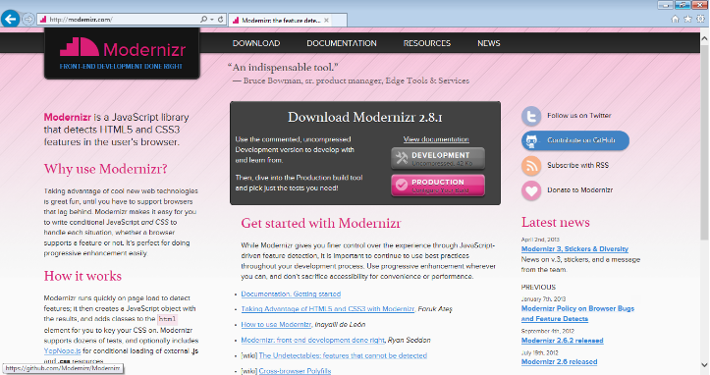Modernizer is a Javascript library that detects which HTML and CSS features are available in the user browser and allows the developer to test for these features and use them in their code if supported by the browser. If the user is using an older browser which does not support a feature used in the application then Modernizer can provide fallback for these browsers via downloadable code called [Polyfill](http://en.wikipedia.org/wiki/Polyfill)’s.

1. JSON (<http://www.json.org/>)

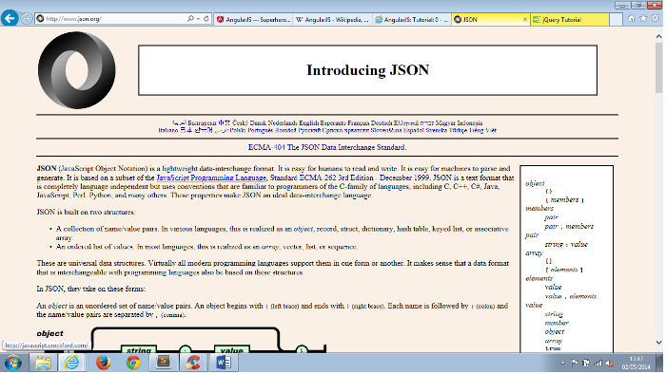JSON (JavaScript Object Notation) is a text-based lightweight open-standard for defining user readable data interface. It is extensive used by sites such as Twitter and Flicker to quickly download data asynchronously, which allows the application to load data in the background and refresh a elements of the page without having to redraw the entire page.

1. AngularJS (<https://docs.angularjs.org>)

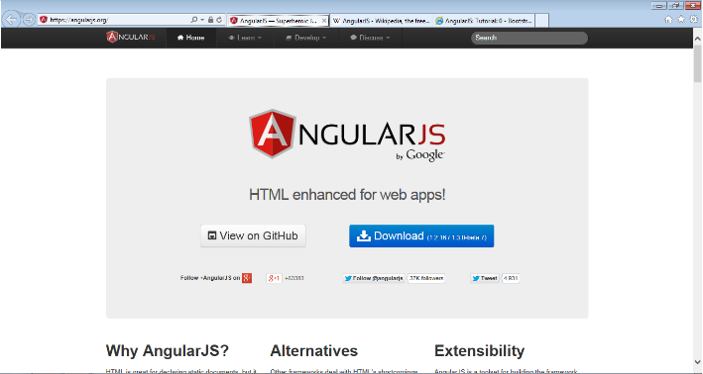AngularJS is a open-source framework which extents traditional HTML to create dynamic single page application. It uses the Model-View-Controller (MVC) pattern using dependency injection to bring server-side controllers to the client-side. AngularJS uses directives to create reusable HTML tags that can handle the behaviour of page elements.

Current Fitness applications

Popular fitness apps such as [RunKeeper](http://runkeeper.com/),[2] and [MapMyRun](http://www.mapmyrun.com/)[3] provide downloadable apps that allow users to track their movements through the motion sensors on their Phone or by purchasing wireless activity trackers such as [Fitbit](http://www.fitbit.com/)[4]. Although most sites provide a logon API’s for all the popular social networking sites such as Facebook, Twitter, Pintrest etc. some sites such as [MyFitnessPal](http://www.myfitnesspal.com/)[5] align themselves exclusively with the Facebook community in order leverage their existing social network.

Some newer sites such as [Pact](https://secure.gym-pact.com/)[6] use a cash rewards system where members who meet their published goals receive. Some sites such as [Jawbone Up](https://jawbone.com/)[7] even provide apps to track and evaluate your sleep patterns.

Conclusion

Bootstrap offers fluid grids with lots of UI Tools and widgets making it ideal for rapid prototyping Bootstrap is a mobile first designed framework and can modified using LESS to improve the default UI. It’s out of the box 12 column fluid grid provides a fully responsive framework which enables agile web development. AngularJS v1.2.16 to provide both the MVC framework and single page dynamic content controls in conjunction with JSON providing the data interchange format for handling back-end fitness data. Modernizer’s Javascript library is a must have in modern web development allowing our application to support as many browser variants as possible. The Bootstrap framework also supports a wider range of desktop browsers than most HTML boilerplates and also newer phone platforms such as Andriod 2.4, Windows Phone 7+ and Surface. (Source <http://responsive.vermilion.com/compare.php>)

Our Solution

The Project greatest constraint of only having 2 Week to design, develop and test our project greatly influenced out framework selection decision. The rapid prototyping advantages offered by using Bootstrap v3.1.1 frameworks template libraries and UI toolsets along with AngularJS v1.2.16 to provide both the MVC framework and single page dynamic content controls in conjunction with JSON providing the data interchange format for handling back-end fitness data were an obvious choice not only from are frameworks we have most experience with and as such were the tools used to develop this project.

User Interface Design

The first challenge in developing any responsive web application is constructing the menu navigations. If the menus are cumbersome or difficult to navigate then the user will be unlikely to hang around to see any of the other application content. The menu must not only be able to present the menu items themselves in a pleasing manner, the menu layout itself must be designed in such a way that users can access it from any number of devices without any issues. We approached the menu design from a mobile first point of view as we intend for the application to be used “on-the-road” as users perform their various fitness activities.

Under the time constraint of the project a simple off canvas menu framework was prototyped directly from code. The content of the menus are fully responsive as shown below:

FitApp Responsive Menu

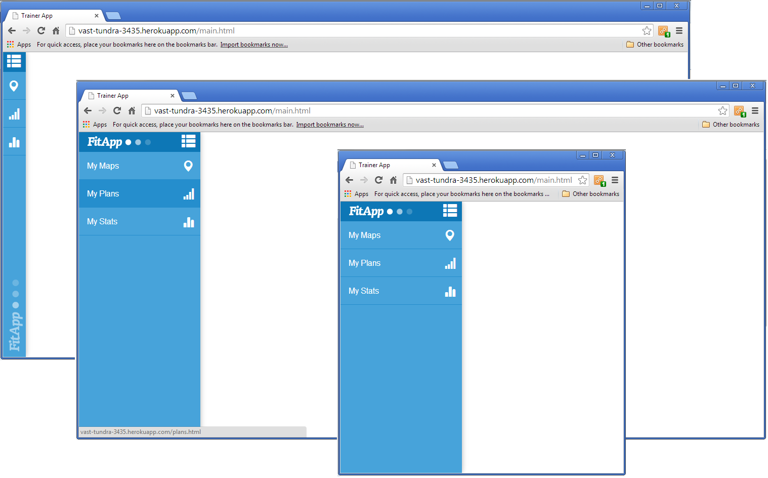

Landing Page

Responsive landing page including Facebook login Authorisation with an active background panel showing an overview of recent training routes and upcoming events maps as shown below:

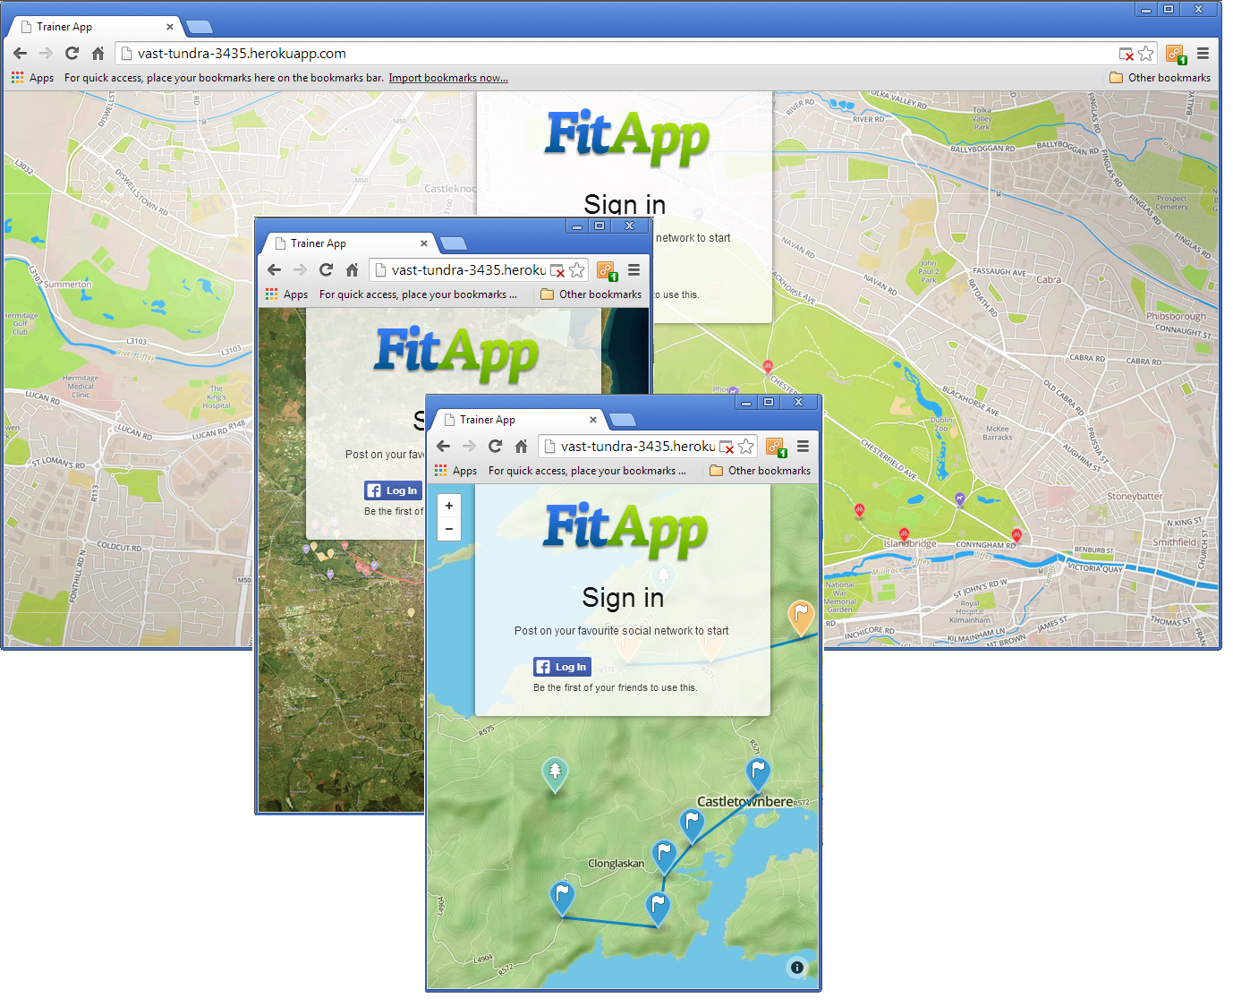

Training Maps

Responsive FitApp Training Maps using MapBox allows the user to create customised Training Trails with customisable in spot editing using selectable colour coded markers that can be added, removed in sequence and with a tour option button which performs an animated Trails Tour onscreen as shown below: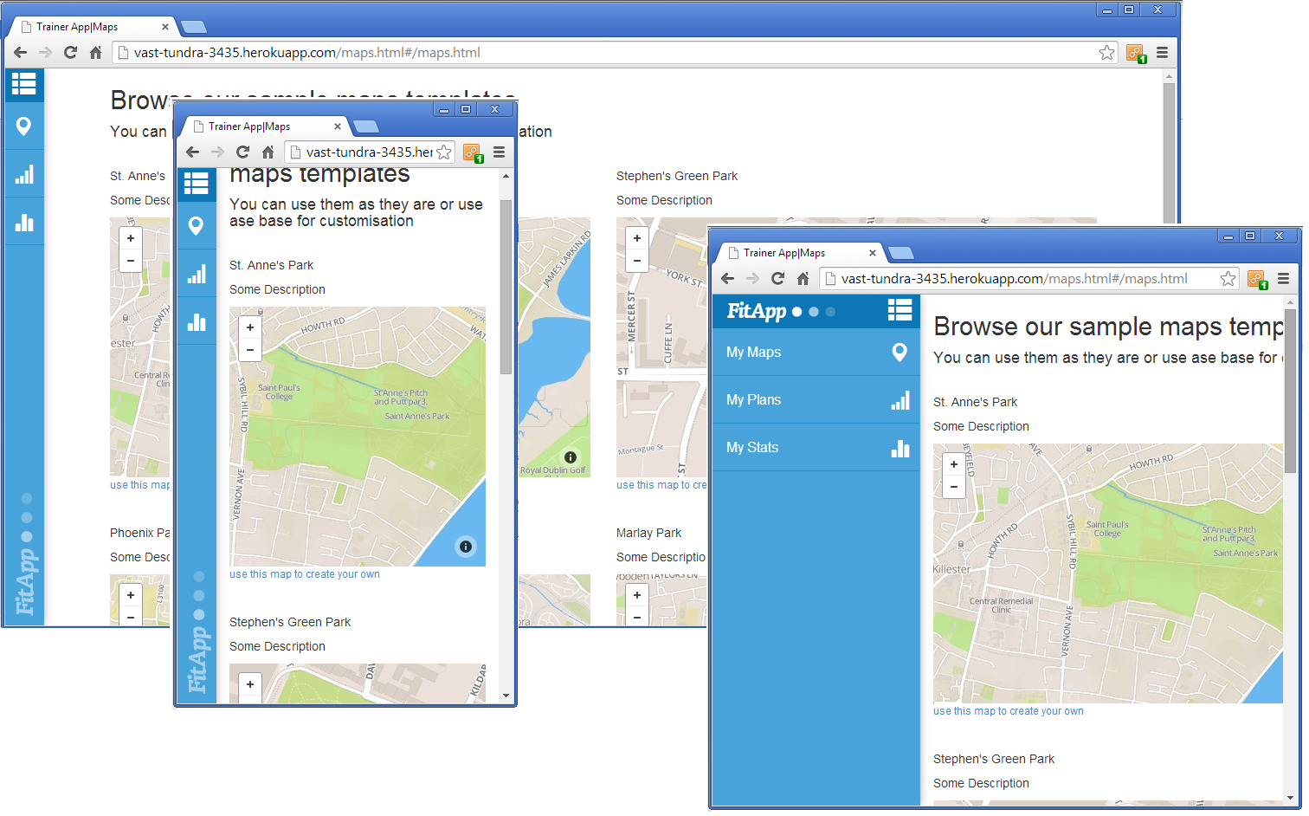

Creating Training Routes using responsive markers:

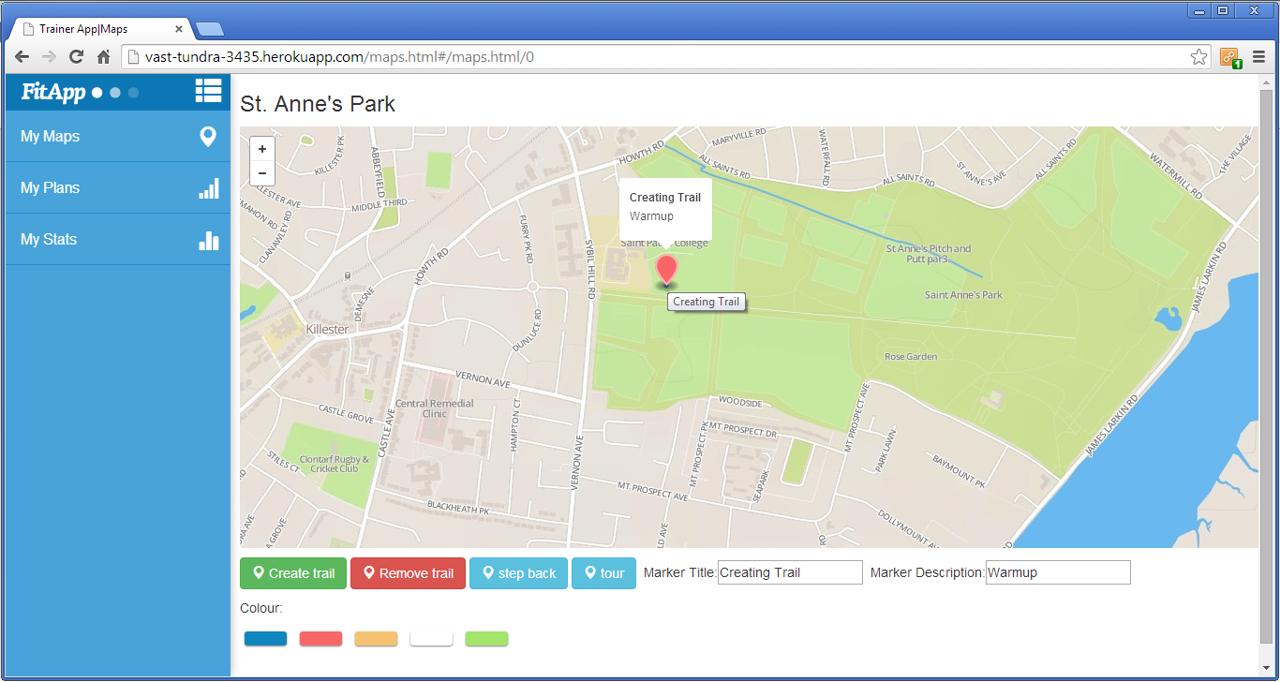

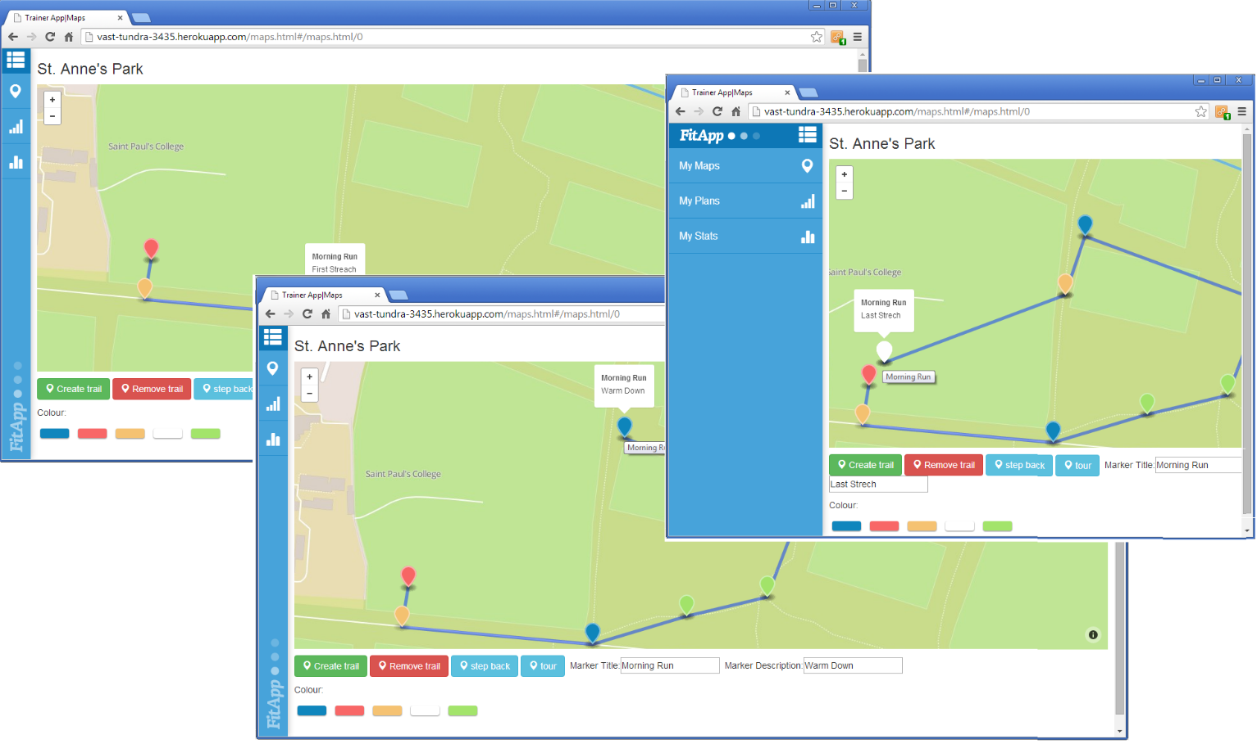

Training Statistics

FitApp My Stat menu option provides responsive Statistics Charts, populated using static JSON showing a range of statistical performance information such as calorie intake, daily and weekly and monthly training statistics in a number of interactive graphical layouts i.e. bar, pie, doughnut and area charts as shown below:

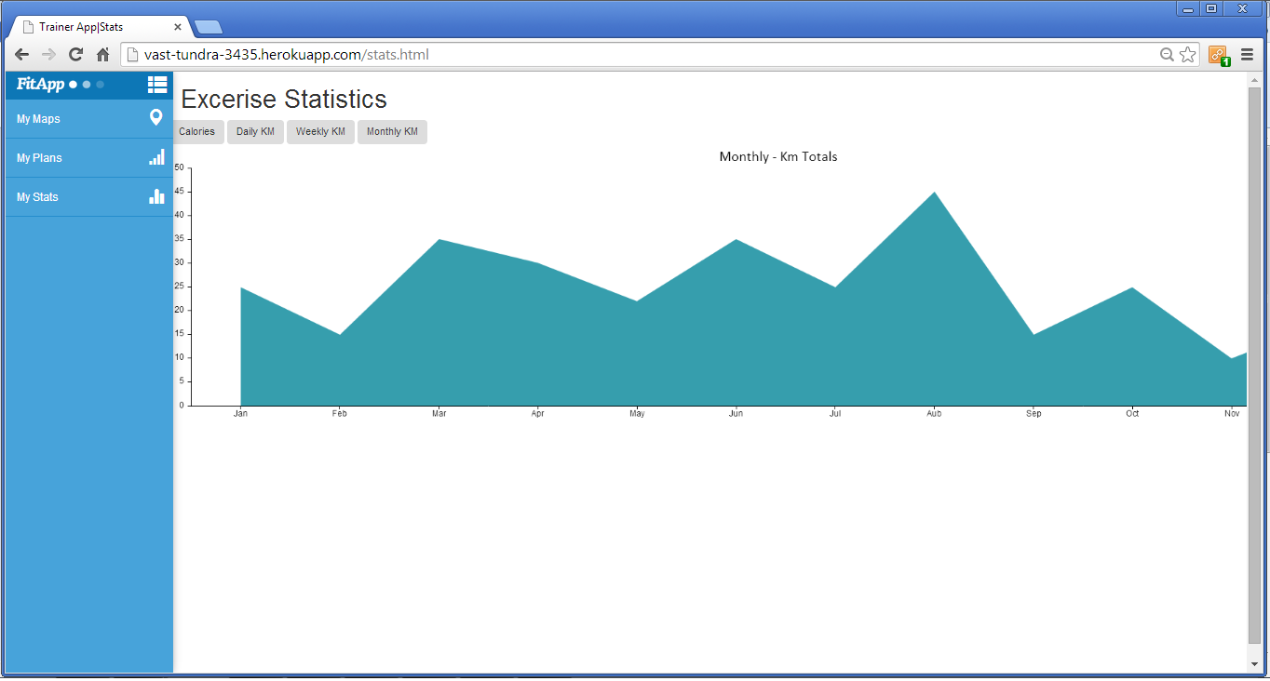

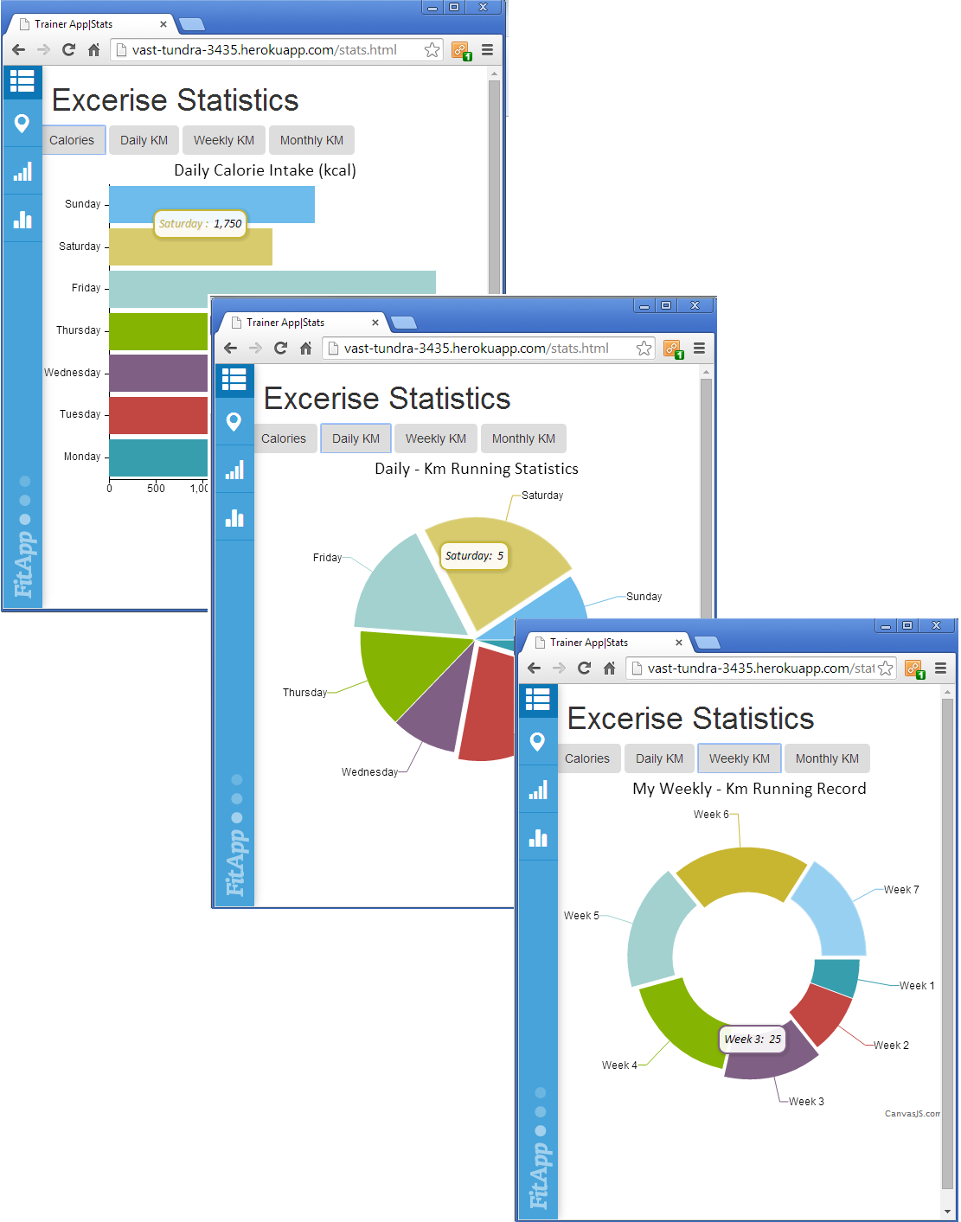

Training Plans

FitApp’s My Plans menu option provide a responsive user customisable schedule of training. Users can select from a predefined set of such as training action points such as: Workout, Training, Cardio, Meal, Supplements and Milestone activities. The created activity schedule is fully customisable with dynamic in element editing on the plan item name and description and sortable by dragging and dropping action items in whatever order the user requires. Training plan items can be updated with a tick mark to indicate completion of the task as shown below:

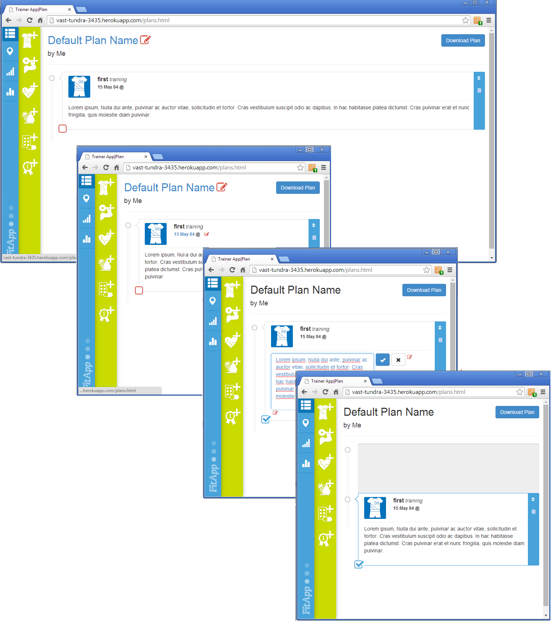

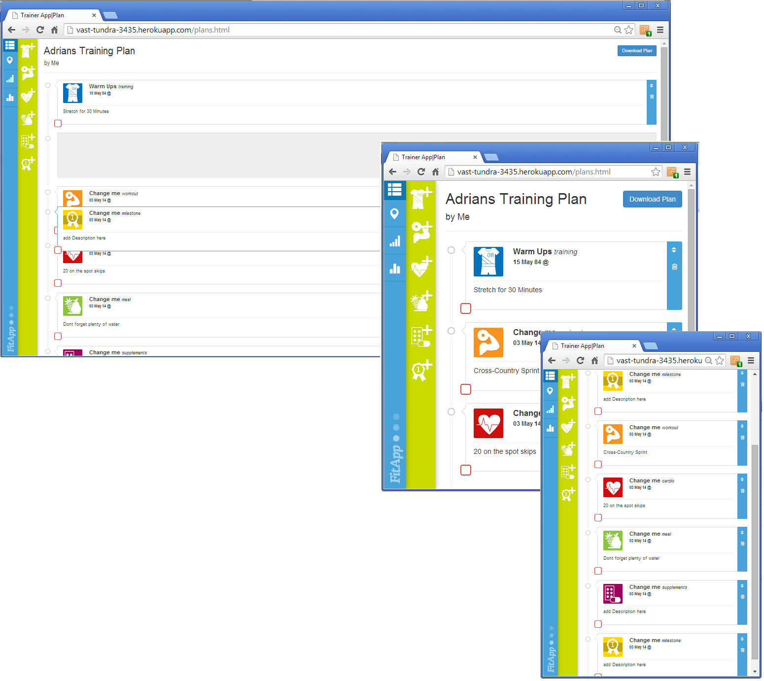

Architecture

Application Architecture:

The FitApp application was developed using Bootstrap, CanvasJS, Mapbox and AngularJS. The solution architectures selected were the frameworks UI most familiar to the team members. The short development timeframe mandated an agile development approach where small components of functionality were rapidly prototyped e.g. off canvas menus and when a stable version was achieved the next requirement is addressed and prototyping continues on this component for a limited period of time until sufficient functionality was achieved.

Security

Additionally security and performance considerations where dropped from our project scope but can be mitigated to some extent by including Facebook authorisation API’s as our main means of user verification.

As the app is not using back end at the moment and there is no sharing of user generated content between the users, there was no critical security issues. All user generated content is being stored in local storage of the browser.

Angular.js provides easy way of sanitising user input and that and is the main form of security in FitApp applet. The Facebook login has no means of preventing user from accessing certain parts of an application, therefore its main function would be for purely marketing purposes.

Toolkits and Frameworks

In order to meet these design goals within our agile development schedule we decided to use a simple responsive off canvas menu in JavaScript using existing CSS tag functionality. Building on this responsive menu using additional JavaScript API to add mapping functionality, drag and drop scheduling layouts and statistical graphing API’s allowed us to implement the core functionalities required by the project requirements.

Additional as the constraints implied for the smaller devices would then not prove to be an issue on the larger screen format devices when the user accesses the site from either their home or work device e.g. tablet or desktop devices.

Bootstrap and family of icon fonts

We used Bootstap 3.1 with font awesome and glyphicon font family for a base template. I gave us efficient styles we are already familiar with therefore usage of Bootstrap speed up design process. We used it mainly for its responsive grid, and nifty js plugins array (tooltips, modals). An attempt was made to make it leaner and integrate Bootsrap with Skel, however proven to be too time consuming. However, we believe such an integration or redesign how Bootstrap is being applied on DOM will give better and more efficient results. Usage of Bootstrap forces using JQuery library.

Angular JS

Main JavaScript framework used in the project was Angular JS as its growing popularity makes it becoming an industry standard.

We implemented 3 angular apps in the project that handle and organize code for maps, plans and stats.

It took us a while to get used to certain way of doing things inside angular app but it turned out to be good choice as it forces modular development, and keep code organised as app was growing.

Mapbox

Mabbox is a map service that provides both JavaScript library and CSS. We didn’t harvest the full benefits of mapbox as it’s designed to map big data onto maps.

In our project we used it for its JavaScript library which is built atop another – Leaflet, and as an afterthought we should be using leaflet alone.

However it gave us good experience and insight into advanced JavaScript and htm5, and what is possible using both of them.

Data Transfer Strategies

Despite the limited schedule we were still able to rapidly develop a responsive application which demonstrate some of the key client side components of a modern rich internet application.

As we mentioned before, we are not using backend in our application so the data transfer is limited. Apart from initial pull of JSON data the app can operate offline and store user generated data in local storage.

It makes perfect preparation for an app that will be operating often in offline mode and connect to a server only when it’s necessary. For plan download we are using Data URL and Canvas combo. It makes it lightweight and secure.

For the JSON AJAX call we are using Angular http service. After that data is turned into JavaScript object that is turned into string and saved as such in local storage. From that point storage data are main place to store data which makes app good starting point if some backend was to be developed.

For plan download we used data URL which do not need to use any backend as well and are lightweight. Below screenshot of how we implemented it.

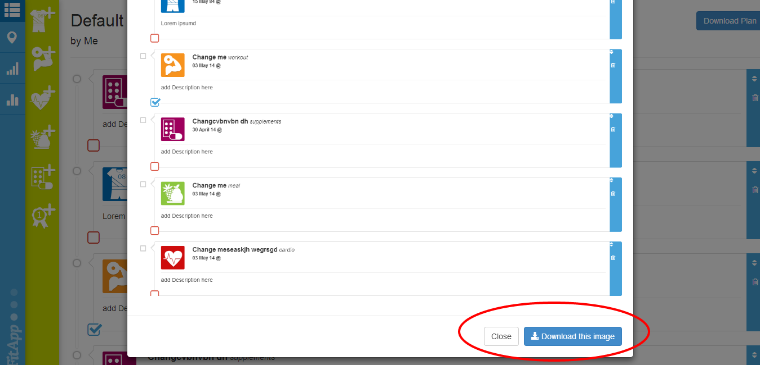

Evaluation and Testing

We wrote some test to evaluate functions within angular apps however it turned out more difficult than anticipated to get angular working with jasmine. It requires a lot of dependencies and additional libraries to make jasmine understand angular syntax.

Despite we have testing framework in place we have not manage to run the tests.

Summary

Despite the limited schedule we were still able to rapidly develop a responsive application which demonstrate some of the key client side components of a modern rich internet application. Responsive single screen menus, interactive maps with route tracking, JSON data exchange and customisable statistical graphs. Additional data generating applications could be integrated into the FitApp to allow the user to generate their own geo-location data and even heart rate monitoring data through the use of wireless activity trackers and innovation in mobile phone technologies such as the new Galaxy S5 smartphone[8] or Gear 2 smartwatch and Gear Fit fitness band unveiled recently[9].

1. <http://www.flurry.com/bid/103601/Mobile-Use-Grows-115-in-2013-Propelled-by-Messaging-Apps#.U2JdAeIvBJ0>
2. <http://runkeeper.com/>
3. <http://www.mapmyrun.com/>
4. <http://www.fitbit.com/>
5. http://www.myfitnesspal.com/
6. <https://secure.gym-pact.com/>
7. <https://jawbone.com/>
8. <http://news.yahoo.com/samsung-unveils-phone-heart-rate-monitor-193026886.html>
9. <http://www.independent.ie/business/technology/exclusive-getting-to-grips-with-samsung-galaxy-s5-30037269.html>